RESULTS AND VISUALIZATIONS
YOLOv9 Performance Metrics:
Class | Images | Instances | Precision (P) | Recall (R) |  | mAP50 | mAP50-95
all | 127 | 909 | 0.816 |  | 0.707 | 0.779 | 0.461
fish | 127 | 459 | 0.873 | 0.720 |  | 0.793 | 0.435
jellyfish | 127 | 155 | 0.850 | 0.871 |  | 0.919 | 0.535
penguin | 127 | 104 | 0.706 | 0.702 |  | 0.700 | 0.311
puffin | 127 | 74 | 0.754 | 0.568 |  | 0.668 | 0.322
shark | 127 | 57 | 0.783 | 0.632 |  | 0.687 | 0.427
starfish | 127 | 27 | 0.899 | 0.667 |  | 0.816 | 0.613
stingray | 127 | 33 | 0.846 | 0.788 |  | 0.867 | 0.582

The YOLOv9 model was evaluated on 127 images with 909 object instances across multiple marine species. The overall precision (81.6%) and recall (70.7%) indicate reliable detections, while mAP50 (77.9%) shows strong accuracy at a 50% IoU threshold. However, mAP50-95 (46.1%) suggests challenges in precise localization.

Confusion matrix

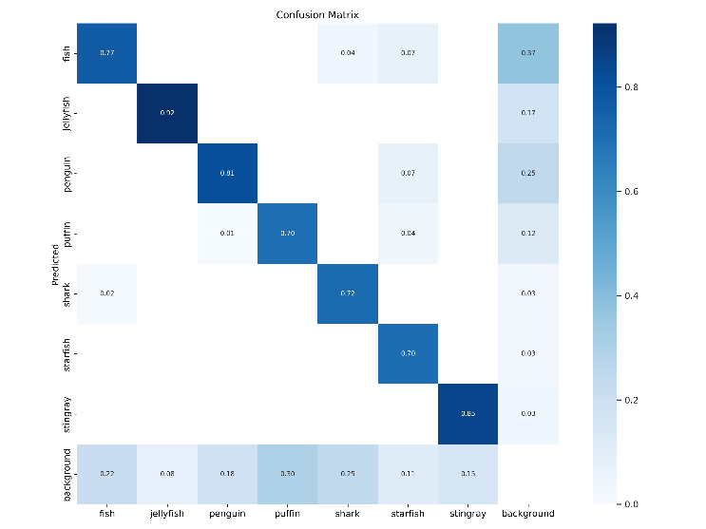

The above confusion matrix determines the YOLOv9 model's performance in classification of marine species. On the diagonal, it will be a correct prediction of high accuracy for jellyfish (0.92), stingray (0.85), and fish (0.77). Errors are those that occur diagonally: fish mislabelled as background (0.37) or penguin (0.07). Some confusion appears between puffins and penguins, probably based on appearance. Sharks and starfish have moderate values (0.72 and 0.70). The background predictions overlap into multiple classes and indicate that separating objects from irrelevant areas is difficult. Overall performance is strong, but fine-tuning and data augmentation could improve underperforming classes and increase the reliability of the model.

Faster RCNN Performance Metrics:

Metric | Faster R-CNN
Precision | 93.02%
Recall | 85.11%
Training Value | 85.71%
False Positive (FP) | 30
False Negative (FN) | 70

Faster R-CNN demonstrated high precision (93.02%) and good recall (85.11%), indicating strong detection accuracy with minimal false positives. The training value (85.71%) suggests effective learning and generalization.
Key Observations:
- High Precision (93.02%): Most detected objects were correctly classified, reducing misclassification errors.
- Good Recall (85.11%): The model effectively detected the majority of objects but missed some instances.
- False Positives (FP = 30): Few incorrect detections, implying reliable object classification.
- False Negatives (FN = 70): Some objects were missed, indicating potential for recall improvement.

Comparative Analysis:
Metric | YOLOv9 | Faster R-CNN
Precision | 81.6% | 93.02%
Recall | 70.7% | 85.11%
Training Value | 77.1% | 85.71%
False Positive (FP) | 124 | 30
False Negative (FN) | 229 | 70

The above experimental results prove that the YOLOv9 and Faster R-CNN models are valid for underwater fish detection, and both algorithms have their advantages. While detecting in real-time YOLOv9 shows great performance, in more complex conditions, Faster R-CNN provides more accurate results. The performance of YOLOv9 and Faster R-CNN was evaluated in terms of underwater detection accuracy. Both models have been compared in terms of precision, recall, and overall detection accuracy. According to the analysis, Faster RCNN has outperformed YOLOv9 in terms of detection accuracy. Faster RCNN is observed to provide more accurate results in terms of under water fish detection and species classification.

